Scanning system tutorial

What scanning system is?

Scanning system is a server-client based system for collecting and storing images of vouchers. It contais centralazed image database store, central web server and many clients.

What images formats are supported?  
All known image formats (more than 20) are supported by the system.

Which devices can be used for scanning vouchers?

Any model or make of scanner, camera, mobile phone, video recorder or another device capable to produce an image.

How many items a voucher can contain?

Vouchers are stored as data packages. One data package can contain unlimited number of items (images, attachments, additional documents, text files, office files, sounds and video files and etc.). The only limitation is size of package. System components restrict the size of a package up to 50MB. Regular package is between 100kB and 200kB.

Are images protected during the transfer? How are they stored?

The system use the fastest communication protocol TCP channel to transfer data. The server connects its clients over secured (encripted) connection. The server connects database over secured (encrypted) connection. Images in database are stored encripted.

What barcode formats and layouts are supported?

System can read any known barcode or quarcode format. All companies barcode layouts are supported by the system.

Are credit card details protected of viewing?  
Curently the system finds and covers credit card codes in Spain vouchers.

How to deploy scanning application?

Application is deployed by simple file copy operation. To run, it requires Windows OS, at least two cores CPU machine and NET Framework 4.

Is the system linked and integrated into TRS? Are images visible in TRS?

Taken images are fully linked to records in TRS database. All existing images are visible in TRS voucher page.

The system shows vouchers organized in folder tree. Why that is so and how many vouchers a folder can be?

Trees allow quick and easy access and observation of big data structure. There is not technical limit how many vouchers there are could be in a folder. However in purpose of speedy access it’s recommended the number of images in folder not to extend over 3000.

Is there site for quick access to database image store?  
There is one. All images are also visible in a quick and reliable web based MVC application. All companies emploies having TRS access are now able open, see, print and download those images. This application is going to redesign and extent for showing images to merchants and external company partners.

How to use scanning application?

1. How to log in?  
   Start the application. Authenticate by using TRS account   
   (user name, pass and country)

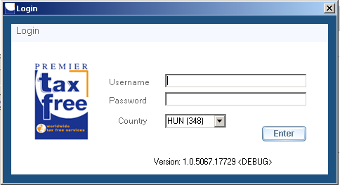

Fig.1

1. How to find the version of my application?  
   The version of application is shown on the login screen at the bottom of the window.  
     
   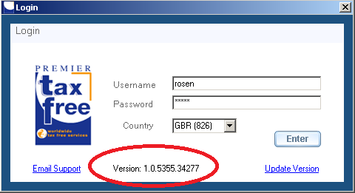

Fig.2

1. How to open the scan tab?  
   Click on the Scan tab header.

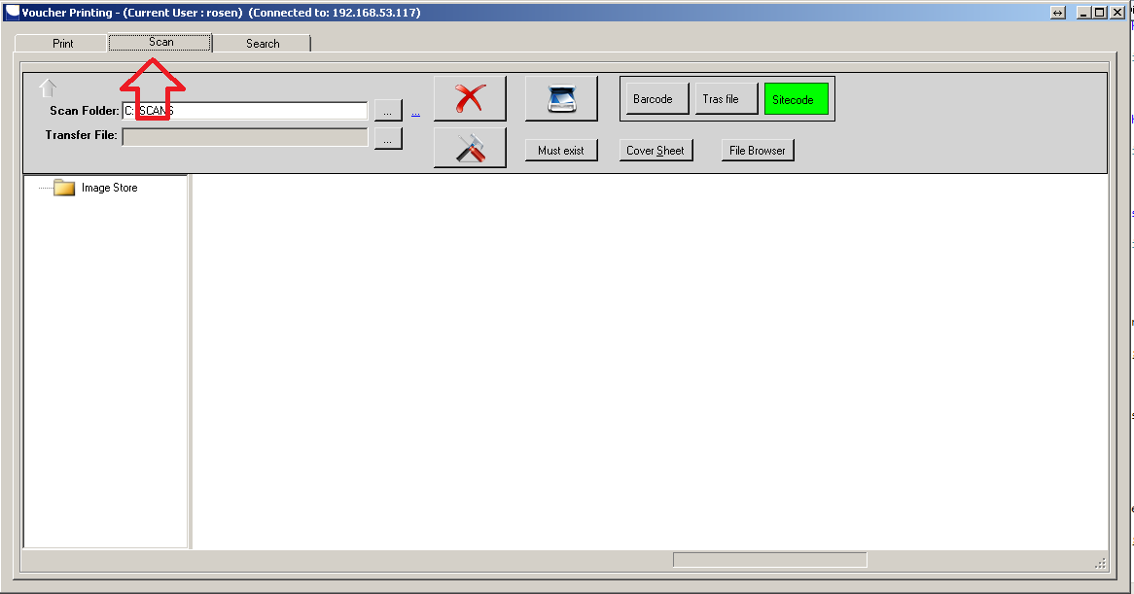

Fig.3

1. How to browse the local scan folder?  
   Click on the button next to scan the folder box and browse the folder structure.

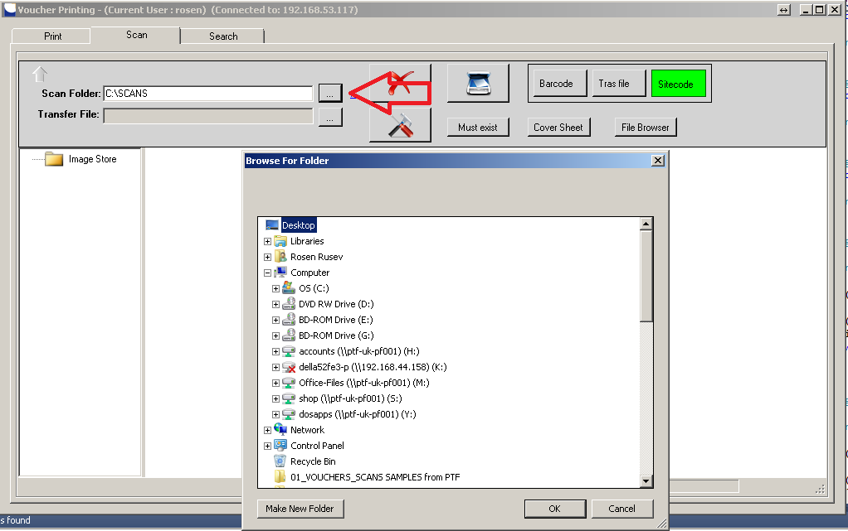

Fig.4

1. How to open the Image store?  
   In tree view, click on the Image Store node and open the node wanted.

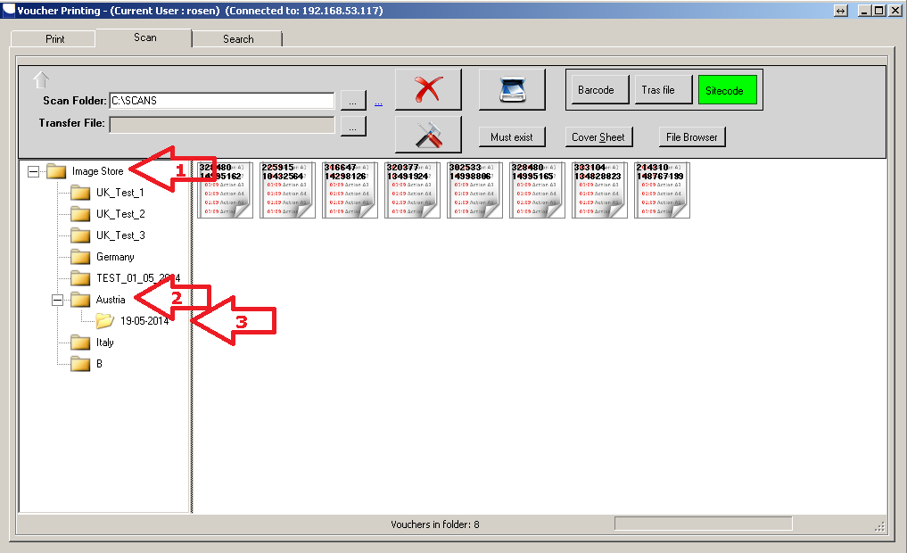

Fig.5

1. How to add a new subfolder in the Image Store?  
   Right click on node and select “add node” option. Enter name of the node. You can also delete a node or all nodes.

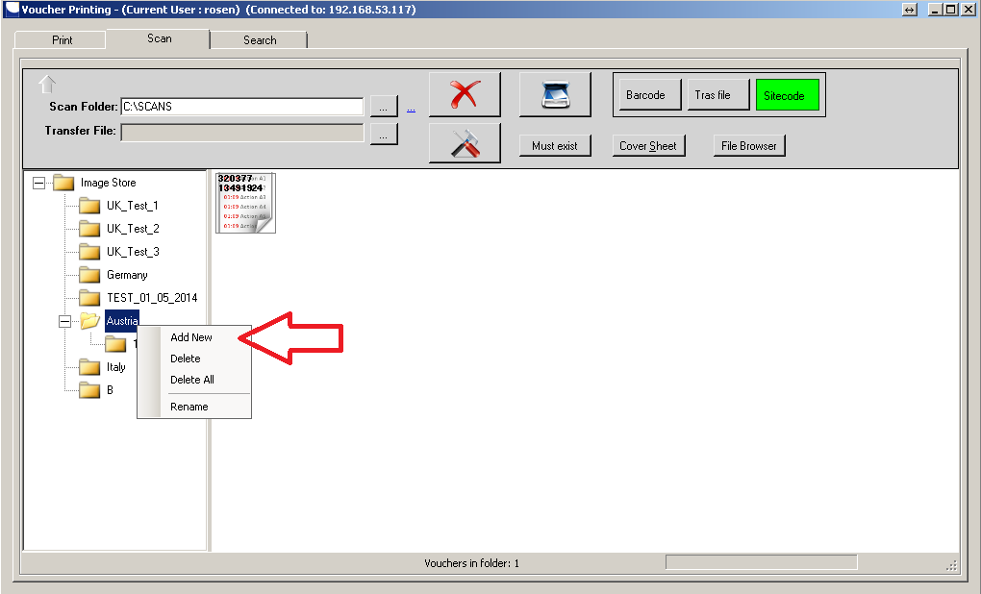

Fig.6

1. How to switch the mode of scan?  
   There are three modes available now: by barcode, by transfer file, by side code. Use the buttons to select one.

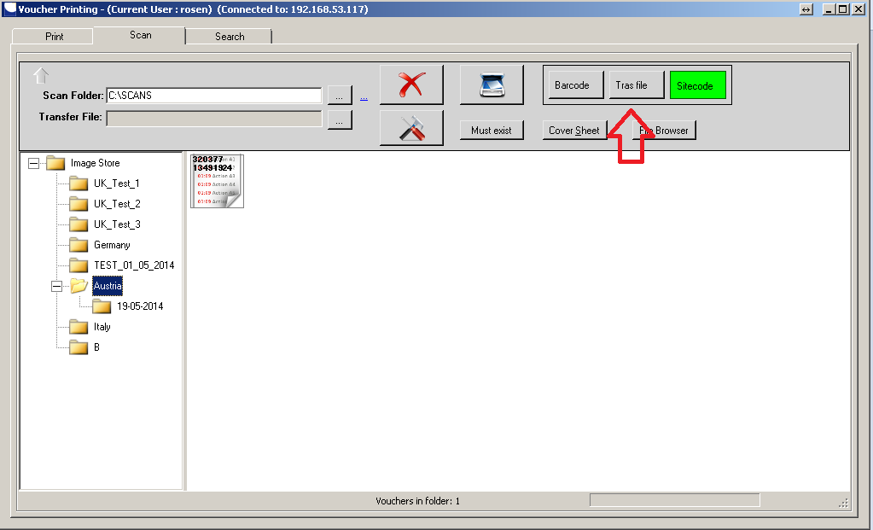

Fig.7

1. How to start scanning?  
   Select local scan folder, remote images store folder, scan mode and click the “Run” button. Set the scanner remote folder to application scan folder and start scanning by scanner.

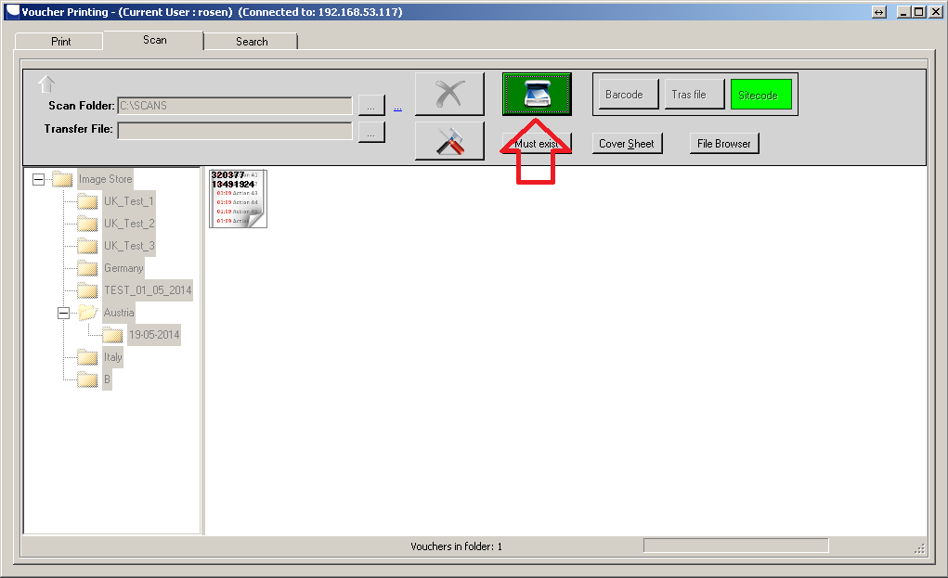

Fig.8

1. How to see my images?  
   Open the image store folder. Right click on any item and choose “Show”.

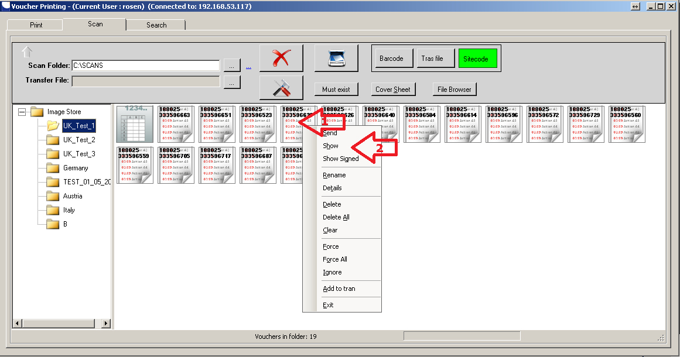

Fig.9  
  
Voucher can contain many images or files. It shows a window containing list of those. Select the one you are looking for and click on it. It opens default system visualizer to show your file.

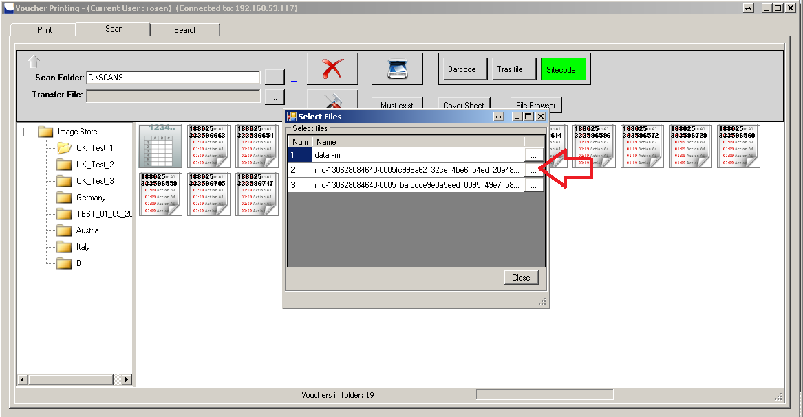

Fig.10

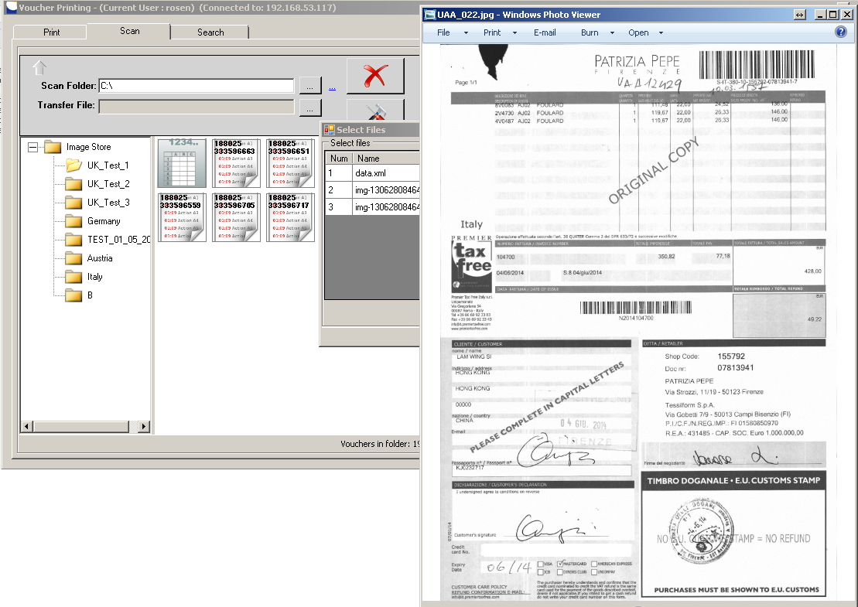  
Fig.11

1. How to see voucher signed?  
   Find voucher you want. Right-click on it, choose “Show signed”. The system shows you select file window, select the one you need.  
     
   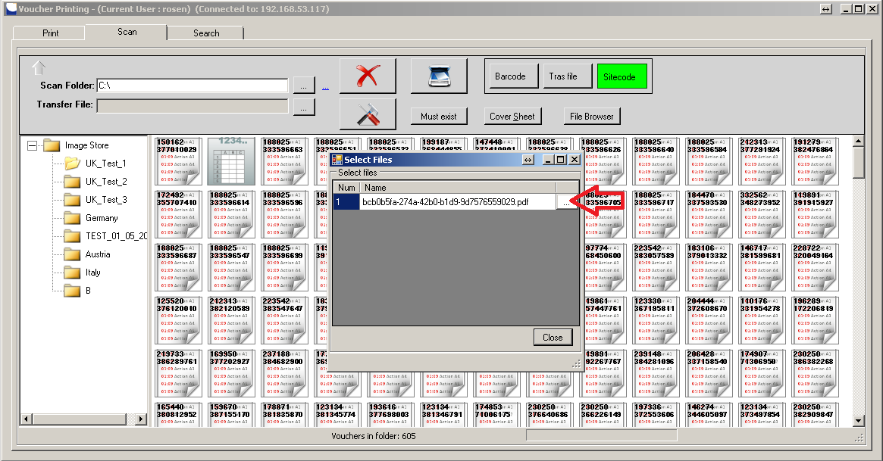Fig.12.   
     
   You will see a signed copy of the voucher.  
     
   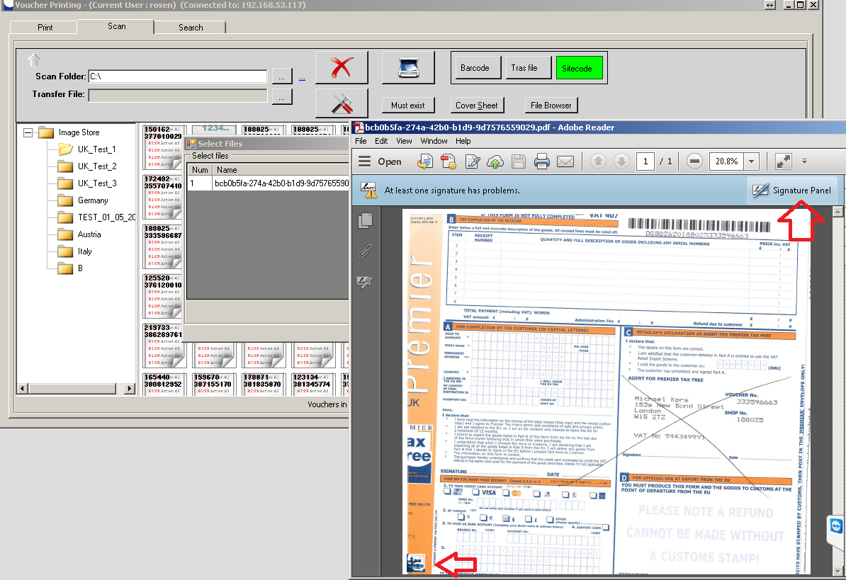

Fig.13

1. How to delete scanned images?  
   To delete image right click on one and click “Delete”.

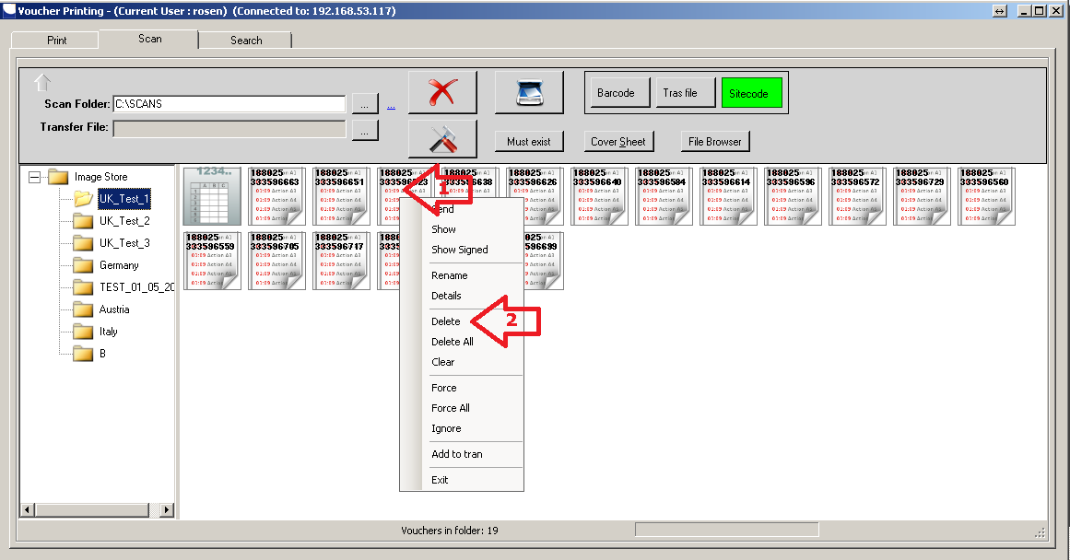

Fig.14

1. What else I can do with my voucher in the image store?  
   You can resend it by clicking “Send”, view it – by clicking “Show”, view signed image– by clicking “Show signed”, name it – “Rename”, view details – “Details”, delete selected – “Delete”, delete all – “Delete All”, force sending – “Force”, force sending all – “Force All”, ignore error during send – “Ignore”
2. How does “Barcode” mode work?  
   It detects voucher by using voucher barcode. The barcode must be present and readable. If the barcode is not found it shows a dialog for manual entry. You need to entry details manually.

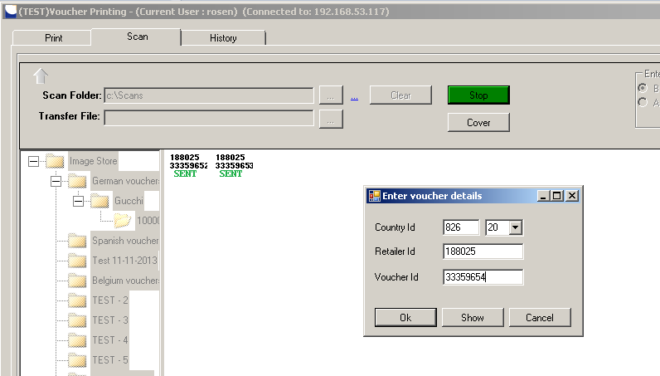

Fig.15

1. How does Trans file work?   
   Trans file is a side code sequence. You provide application with the voucher sequence, order your voucher in the same order and start scanning.

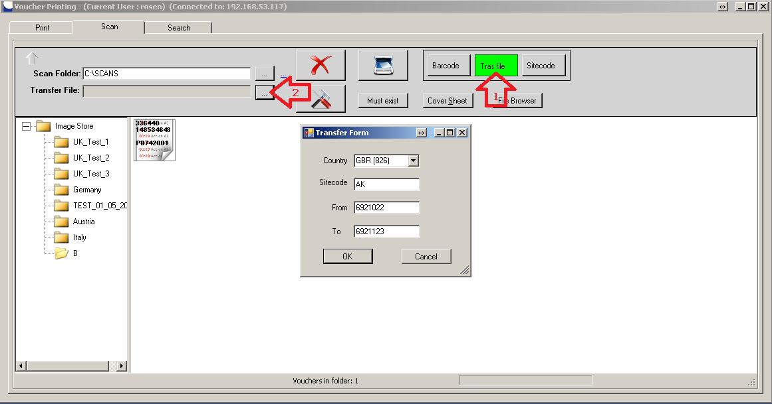

Fig.16  
  
The incoming voucher image is automatically assigned to the next details in the sequence.

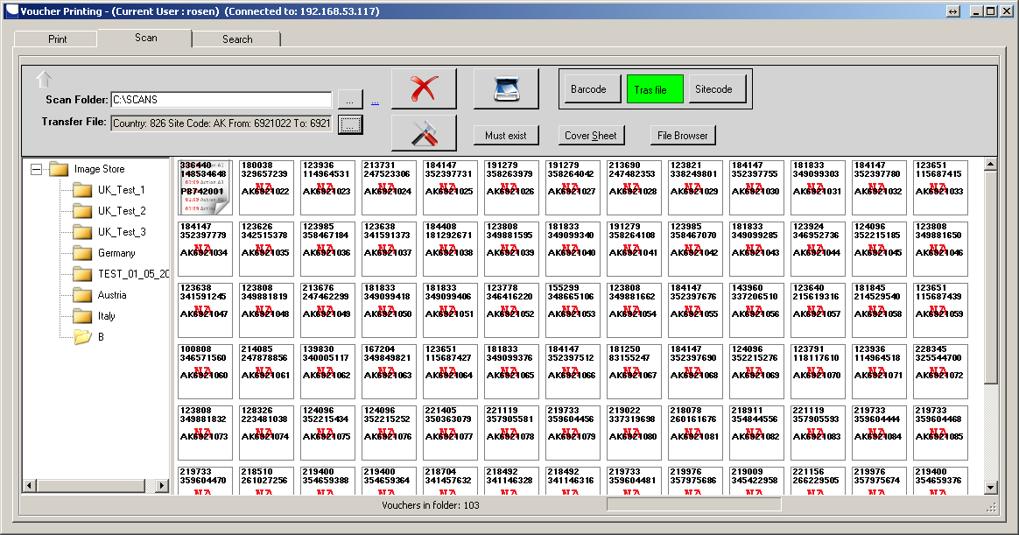

Fig.17

1. How does the site code mode work?  
   It uses name of file to discover the site code of voucher. For instance, incoming file name may be “PB742001.jpg”. System calls TRS server to gather details for the voucher.

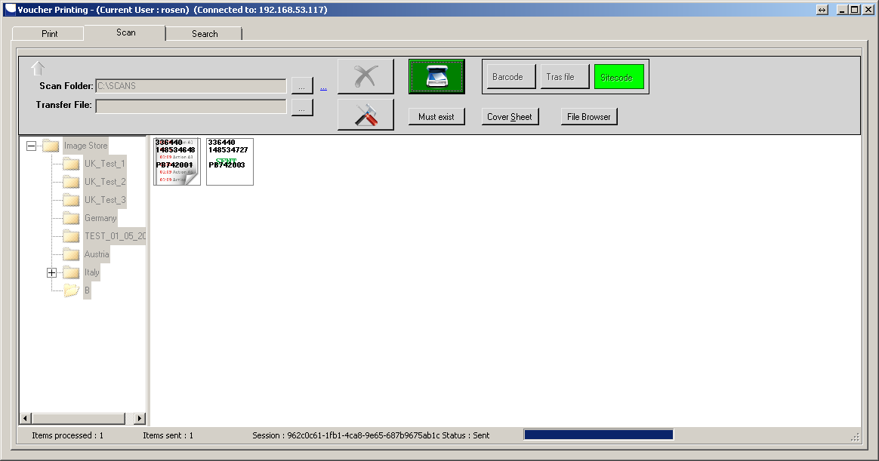

Fig.18

1. How to browse folder structure, find image files and send those to server?  
   Click on “File Browser” button. In folder tree browse your drives. Select your folder. Open it and right click on it. Select “Run Copy”. Application copies your images to scan directories and process those as if they were coming from scanner.

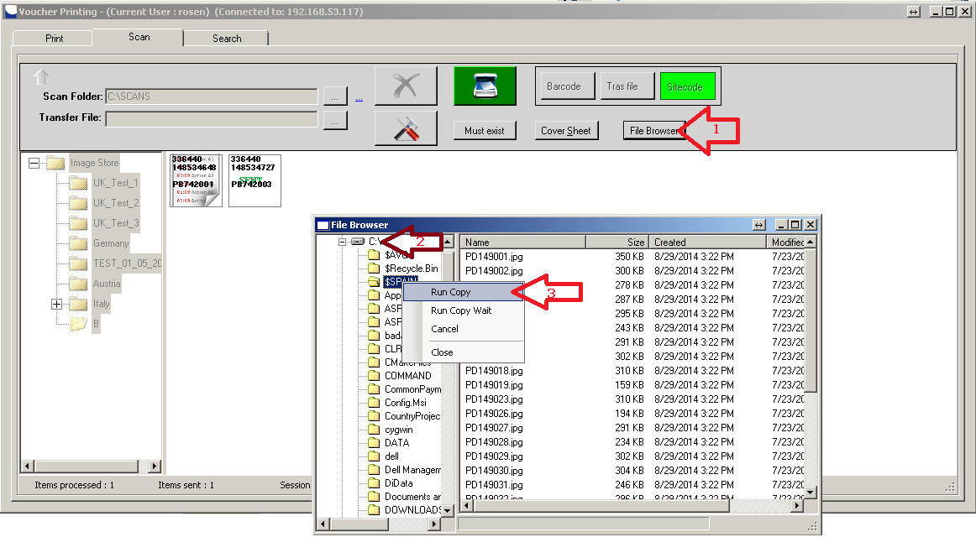

Fig.19

1. How to scan the other files?  
   System is capable of scanning any images. The system processes those without any validation and checks. Start scanning. Click on “Cover Sheet” button. Scan any document; image goes straight away to server. This button will switch off every time you scan.

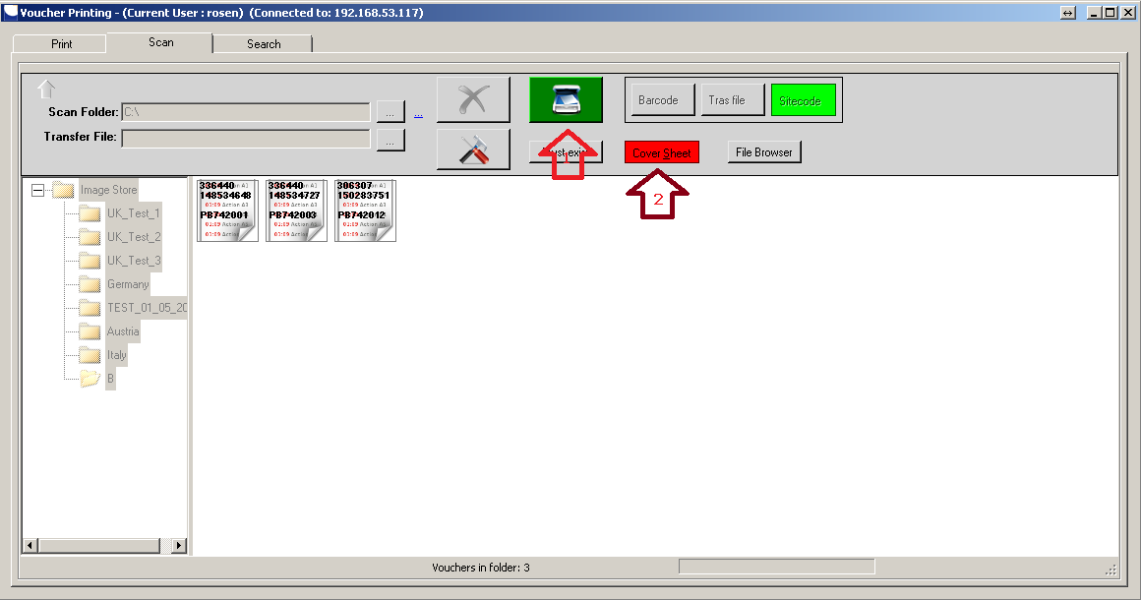

Fig.20

1. How to use the system monitor with flatbed scanner?

Using flatbed scanner requires operator staying beside the scanner. In this case he/she needs to see the process close. Click on “Monitor” button to visualize process monitor window.

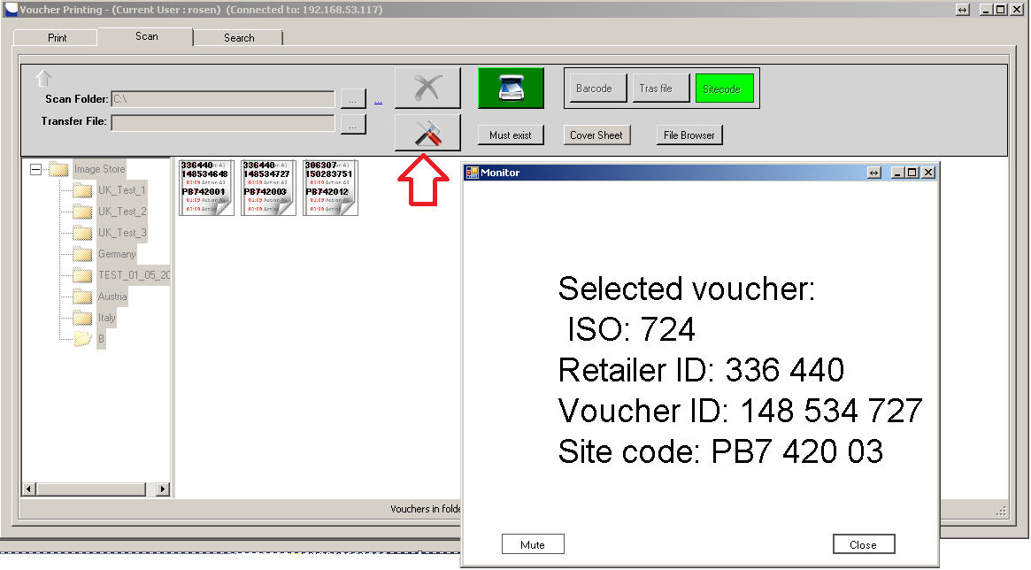

Fig.21

1. How to search for a voucher?

Open search tab by clicking search tab header. Enter any country, retailer, voucher number or voucher date and click the “Search” button. According the filter vouchers appear in grid below. Choose one and right click on it. Select “Show” option.

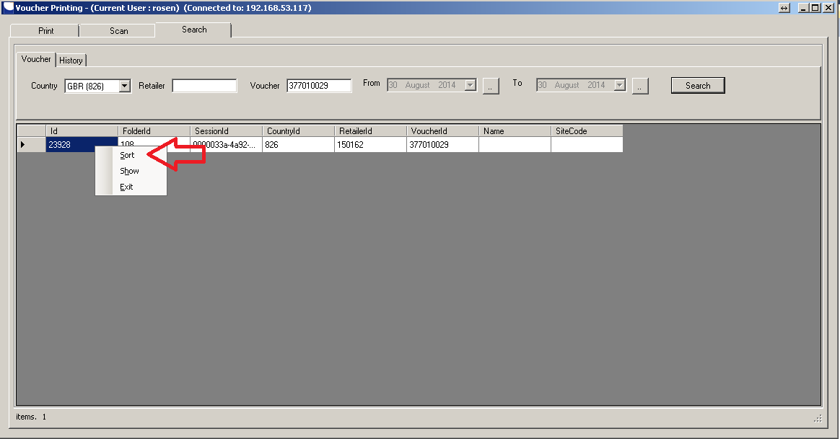

Fig.22

It shows you a list of all files included. Select the one you want to see and click on the bottom. System uses the default Windows viewer to open the file.

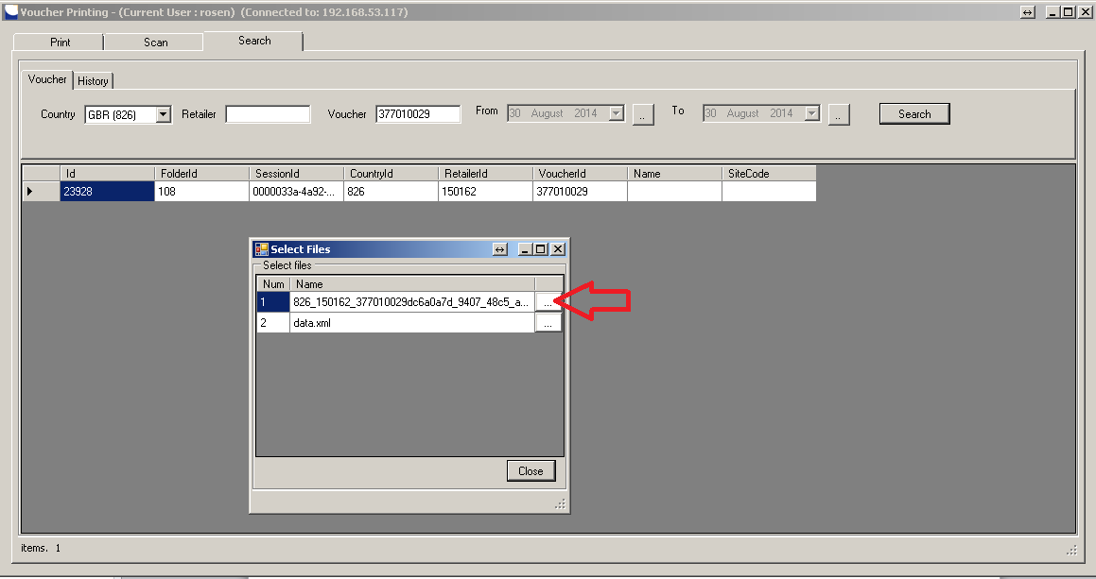

Fig.23

1. How to see a historical list of activities?

Open history tab by clicking the history header. Enter details in filter and click on search. The system shows you a list of all activities meeting the search filter.  
  
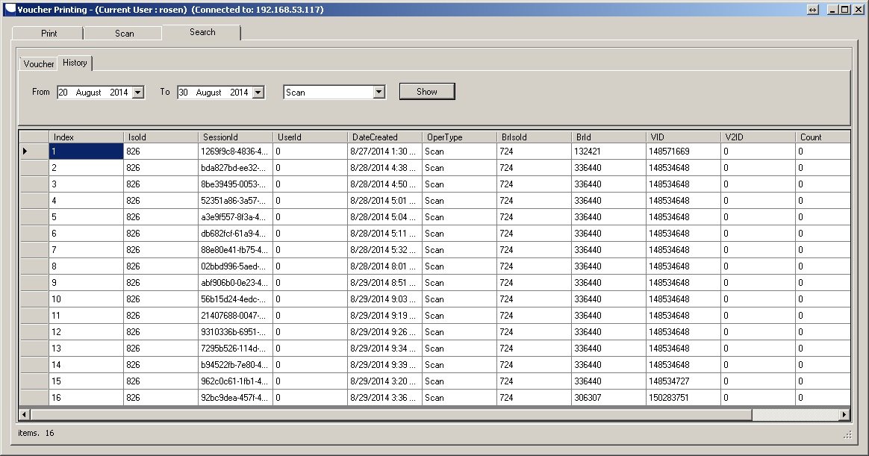

Fig.24

Conclusions

This tutorial is brief and doesn‘t cover all functionalities of the system. The system is still under development and constantly changes.

Contacts

For any further questions or clarifications contact

Mr. Rosen Rusev   
Somerset House,

47-49 London Rd,

Redhill, Surrey

RH1 1LU

Tel: +44 1737 644922

Email: rosen.rusev@uk.premiertaxfree.com